Study

First part:

* Research the average rotation of the wrist

Coupling between wrist flexion-extension and radial-ulnar deviation – Zong-Ming Li *et al.*

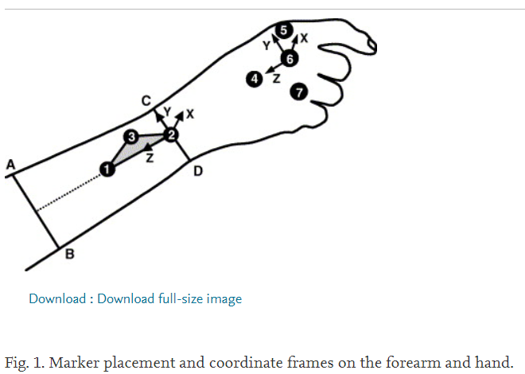

Each subject seated with the humerus at approximately 60 degrees of abduction in the frontal plane and 0 degrees of flexion in the sagittal plane.

Elbow was braced at 90 degrees of flexion, and the forearm was stabilised with nylon straps

<https://www.sciencedirect.com/science/article/pii/S0268003304002396>

‘’The unconstrained RoM in the FE direction was 99.5° (SD 19.5°), 64.8% (SD 7.3%) of which was extension. **The unconstrained RoM in the RUD direction was 51.0° (SD 7.8°), 61.8% (SD 7.5%) of which was ulnar deviation**.’’

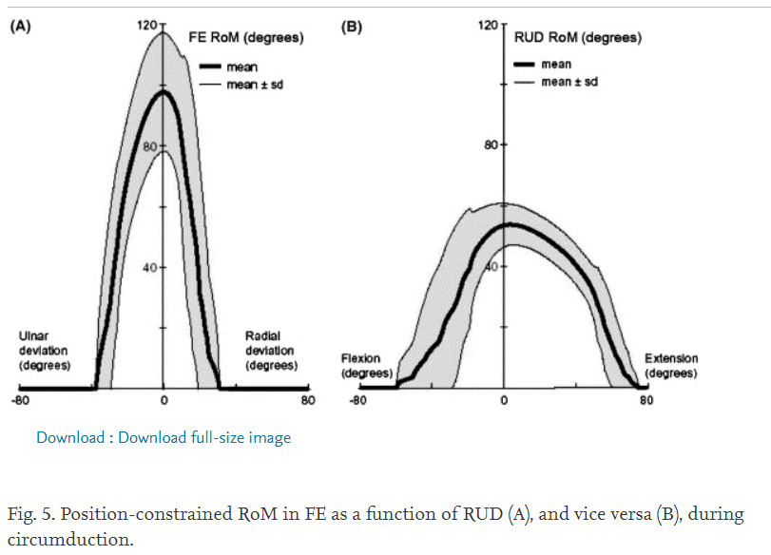

* Decide whether I want it to be an abstract display and/or be the visual representation of a hand rotating
* Same goes for grasping motion as well
  + The visual displays will be abstract to account for the potential that users may synchronise in a different manner
* Store the data of key feature points
* Maybe design some storyboards
  + Please mimic the motion of the object on the screen by rotating your wrist
* ~~Complete EIRA1 form~~
* Carry out study
  + Various speeds
  + Various sizes